**LAB EXPERIMENT 5**

**Aim:** To design Toggle Flip Flop and Delay Flip Flop in Xilinx Software using Verilog language of programming and check its outputs in the ISIM Simulator.

**Theory:**

1. D-Flip Flop: D Flip-flops are used as a part of memory storage elements and data processors as well. D flip-flop can be built using NAND gate or with NOR gate. Due to its versatility they are available as IC packages. The major applications of D flip-flop are to introduce delay in timing circuit, as a buffer, sampling data at specific intervals

Circuit Diagram:

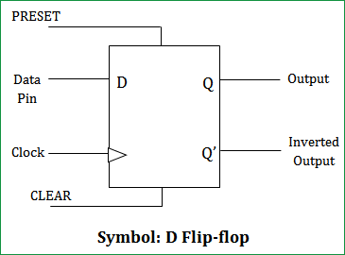

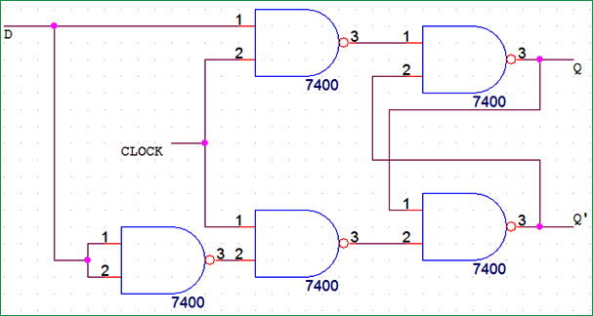

Truth Table:

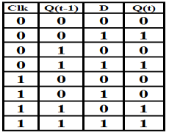

1. T-Flip Flop: T flip – flop is an edge triggered device i.e. the low to high or high to low transitions on a clock signal of narrow triggers that is provided as input will cause the change in output state of flip – flop.

Circuit Diagram:

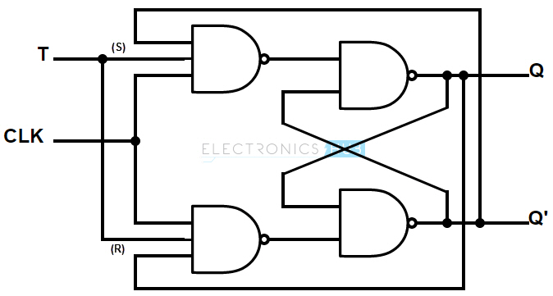

Truth Table:

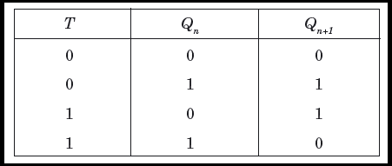

**Verilog Code of the Program and Outputs:**

1. **D-Flip Flop:**
2. **Verilog Code of the Program:**

module d_ff(q,qbar,d,clk,reset);  
input d,clk,reset;  
output q,qbar;  
reg q,qbar;  
always @ (posedge clk)  
begin  
if(reset)  
begin  
q<=0;  
qbar<=1;  
end  
else if(d == 0)  
begin  
q<=0;  
qbar<=1;  
end  
else  
begin  
q<=1;  
qbar<=0;  
end  
end  
endmodule

1. **Screenshots of the Program and Outputs:**

1. **RTL Schematic:**

1. **Toggle Flip Flop:**
2. **Verilog Code of the Program:**

module toggle_ff_062(q,t,clk,reset);

input t,clk,reset;

output q;

reg q;

always @ (posedge clk)

begin

if(reset)

q<=0;

else if(t==0)

q<=q;

else

q<=~q;

end

endmodule

1. **Screenshots of the Program and Outputs:**

1. **RTL Schematics**

**Conclusion:** From this experiment we learnt how to implement a delay and toggle flip flops in the XILINX software. We used the data flow type of modelling in this experiment. We also learnt how to check the output from the truth table.